MRA+MVF Submission on Resource Consent Application LT-2141565

1.0 SUBMITTER DETAILS
Name of Submitter: Milford Residents Association (otherwise known as ‘MRA’), and
Milford village Forum (otherwise known as ‘MVF’)
Address for Service:
Telephone:
Email:
2.0 APPLICANT DETAILS
Application No: LT-2141565
Name of Applicant: NZRPG Management Ltd
Address of Proposed Activity: 143 Kitchener Rd, Milford 0620
Description of Proposed Activity: Resource consent for a Mixed Use retail and residential expansion of the Milford Shopping Centre

3.0 SUMMARY OF EVIDENCE
We oppose the Application as submitted and require further modification
This Stage 1 Application is critical to all parties, as the success of any Outcome on the decisions as to Built Form and its integration within an existing community will have an impact on future community acceptance of such large-scale projects.
MRA+MVF have reservations as regards this application satisfying the Intent of the PC34 Environment Court Decision, particularly as to Bulk and Massing, and to satisfying the Urban Design requirements of the Unitary Plan.
3.1 Master Planning
NZRPG has submitted an application for Stage 1 of the whole site development which shows totally different building platforms from the PC34 Environment Court decision.
MRA+MVF strongly believe that a revised Master Plan is required showing the total development within a staged environment, including a peer review of the total massing and disposition of buildings to each other, including off-site effects on the wider existing Milford environment, to ensure that this large-scale development integrates with the context and character of the existing Milford environment.
3.2 Peer Review
A peer review of both Urban Design and Building Design for Special housing Areas is currently practised when an application is made to the Housing Project Office (HBO), and MRA+MVF are firmly of the opinion that projects of the scale of this application request a peer review by the Urban Design Panel, with the results made available to the community.
MRA+MVF seek a peer review of this Stage 1 Project, for both the Urban Design context and the Building Design textural context as an essential part of the Process Planners Report, especially as regards:
- Massing and Modulation to prevent continuous, boxy, and slab-like buildings out of context and character with the existing Milford environment
- Building Design texture and form to represent the human scale or ‘Urban Village’ context and character of Milford
- Public Open Space at frequent intervals along the street frontage, indented around the perimeter of the project and suitably landscaped to promote the sense of human scale and urban village texture
- Setbacks at street level for the apartments fronting Milford Rd and Ihumata Rd to integrate with the context and character of properties opposite (refer approved 2009 apartments)
- Integration of Buildings with the surrounding streets, including detail design of access pathways and connections external to the site for pedestrians and cycles incorporated within the Process Planner’s report. This concern has been raised at previous hearings and nothing has been actioned
- Lower Height with Setbacks to upper levels of buildings fronting Omana Road, to better integrate with the street and residential zones to the north and across the Wairau estuary, as per Fig 11 for Mixed Use zones in the Unitary plan
- Apartment Carparking spaces for unit sizes of between 92m² to 125m² requires 2 carparks per unit, and we believe that the number of proposed visitor parking spaces for 121 units is insufficient.
- Traffic - Since PC34 there has been an increased Council focus on intensification and as such, Milford will see more apartments. MRA+MVF seek a Traffic Peer review as to the traffic and carparking limitations on the roading network and intersections, particularly the Omana Road roundabout on the northern side.
- Amenity – Given the scale of the whole site development, there should be some wider community amenity contributions including:
- Open space
- Landscaping
- Stormwater Management including Wairau estuary sediment and particulate controls
- Public Streetscape elements including seating, signage, raised crossings to emphasise the importance of the public realm and pedestrian safety versus the previous dominance of the car
- Community Facilities - The increasing pressure on local schools, community facilities and open space areas which need to be increased to reflect intensification, and is an essential and central part of any community development.

4.0 SUBMISSION DETAILS
MRA+MVF reasons for opposing this application without further modification
4.1 Intensification
MRA+MVF wish to record that they are not against intensification or this project per se, but, following the costly and time-consuming PC34 decision brought to the Environment Court by the Applicant, MRA has a responsibility to fairly represent the wishes of both its members and those of the wider Milford community, especially as regards the integration of the proposed buildings into the existing (and future) community culture, character and environment.
4.2 Council Responsibility & Obligations
Council has a responsibility and obligation to ensure that the criteria for evaluating any such large-scale project achieves a balance between the opportunity for commercial / economic growth, and the long-term community need for a high quality of urban design and buildings, and a public realm or amenity value that enhances the community well-being and a sense of pride and belonging.
Evaluation criteria includes the integration of the project into the existing community both within and external to the development, and quality design of :
- Urban design and relationship of the whole site to the adjacent residential properties
- Buildings and structures relating to the human scale
- Provision of community spaces including pocket parks around the perimeter of the development
- Integrated pedestrian and cycle pathways giving access and external to the development
Forward-looking developers now recognise the long-term economic benefits of a quality designed environment that attracts people to enjoy the inherent character, culture, arts, streetscape, and landscape of an active environment, and retain a loyal clientele.
So there is both an obligation and responsibility on both the Developer to ensure a high design standard and a sound and forward-looking project, and the Council to evaluate the submission for the long-term benefit of the community, rather than accepting the premise that any average commercial development is good for the economy and short term profits.
4.3 Economic Opportunity vs Community Responsibility
MRA+MVF recognise that there must always be a finely-tuned balance between:
- the provision for future growth and planned intensification in a hierarchy of centres and suburbs yet retaining a diversity of character, style, imagery, and landscape in a balanced environment
- the economic opportunity and financial viability afforded to an Owner who develops a significant commercial property at the heart of a Community, and
- the enhancement of public spaces and amenities both internal and external to the building for the enjoyment and empowerment of the community, and which integrates the development into the existing (and future) community landscape.

Milford centre with its unique location at the junction between Lake Pupuke, Wairau Estuary and Milford Beach, and had been denoted as a ‘Town Centre’ in the hierarchy of centres (although it is only 1.5km distance from Takapuna metropolitan centre).
Milford Centre’s role is generally defined as a high quality node, as an active people-friendly place, and as the first planned Town Centre in Auckland to showcase Auckland council’s commitment to its slogan of ‘the most liveable city in the world’, and with development potential to ensure a balance between its role as a sustainable economic commercial centre, and creating the highest quality creative environment to reflect its locational uniqueness, character and cultural heritage.
This is a pivotal site which has the opportunity to reflect the theme of the future Milford which has been likened by its community as an ‘Urban Village’, and one that retains a sense of friendly, human scale, of individual identity, and which empowers a healthy interactive community.

The Milford community fear is that the nearly 100 metre long 10 storey slab building reflects a dominating ‘them and us’ visual imagery, and the four storey apartments built right on the street boundary reflects a harsh central city environment, rather than the current tree and shrub-lined streets opposite the development.
The current submission appears to provide a quality apartment style living to those few who have good views at the expense of the remainder of the community.
This is a pivotal opportunity to determine and ensure the future direction of the Milford character, culture, and heritage values, and celebrate its high quality people-friendly, human scale ‘urban village’ atmosphere, which can be achieved by a lower-rise and more modulated and textural design.
4.4 Site History and Statutory Processes
- Current 1993 Mall - project required limitations of building distance to Milford and Ihumata Rd under the prior North Shore City and maximum height to RL21.0

- Approved 2009 2-3 storey apartments - for Milford and Ihumata Rd in 2009 was designed by Jasmax Architects, and showed the apartments setback to allow a small lawn/garden area which softened the street frontage and related more comfortably with the character of the existing residential zone opposite

- Plan Change 34 - submission by NZRPG to Auckland Council proceeded to the Environment Court where the tall buildings were reduced in height (refer images below) including 3 storeys to the Milford / Ihumata Road frontages
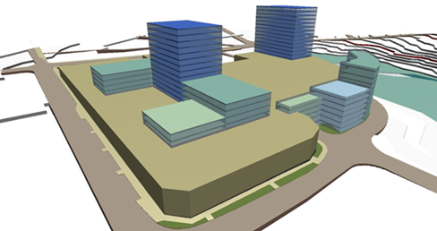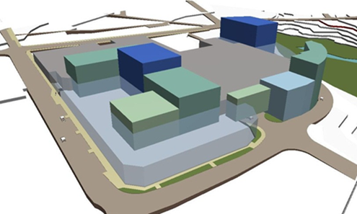
RL59
RL45
RL45
RL33
RL21-3 storeys
RL21-3 storeys
RL38
RL63
NZRPG PC34 Submission PC34 Environment Court Decision
PC34 Extracts from the Environment Court Decisions (refer to Appendix)
- Concerns related to Privacy, particularly that of residents to the north and east of the site
- Amenity issues including over-dominance and visual intrusion, blockage of views and changes to the village character
- Maintain or enhance local character and amenity
- Will the development…have significant adverse effects that cannot be adequately avoided, remedied or mitigated, having regard to the height and bulk of buildings, visual and landscape effects, dominance, shading, privacy, impacts on views and the character and amenity of Milford and the wider environment

Reason for Decision - Policies
4. By requiring that any new development achieves integration with existing development and the surrounding area….
5. By requiring that all new buildings… make a positive contribution to the surrounding amenity, and help to achieve high quality urban design outcomes, including a comprehensively planned, well integrated and attractive centre with an active, attractive, safe and convenient pedestrian environment.

Objective – Milford Intensive Residential Overlay Area - Policies
1. By requiring taller building forms (above 5 storeys) to be set back into the site away from Milford Rd and Kitchener Rd, to ensure a human scale and the protection of street character and amenity
2. By ensuring taller building forms (greater than 5 storeys) are located on the site so as to minimise effects on adjacent sites in terms of shading, dominance, and loss of privacy.
3. By enabling lower buildings (five storeys and below) to provide an appropriately-scaled street edge with taller buildings (above 5 storeys) set back into the site.
4. By ensuring, where buildings are set back from the street, that any spaces between the ground floor of the building/s and the street contribute positively to streetscape amenity

15.7.2.8 - New Buildings located within the Milford intensive Residential Development Overlay
a. Design of Buildings
1) Buildings shall be designed to provide a distinctive silhouette … when viewed from within and around Milford they make a positive contribution to the collective skyline
2) Buildings shall avoid a boxy dominant massing with an appropriate scale at the street level to integrate with the adjacent buildings and open space … etc

Section 15.4 Zoning Framework: Objectives and policies
4. Requires new development to achieve a high quality design and buildt form, to integrate with the surround streetscape and buildings and to contribute to the “centres sense of place”
Policies
3. By ensuring that those potential adverse effects of activities… on the amenity of adjdoining residential areas are avoided, remedied or mitigated.
5. By requiring that all new buildings… make a positive contribution to the surrounding amenity, and help to achieve high quality urban design outcomes, including a comprehensively planned, well integrated and attractive centre with an active, attractive safe and convenient pedestrian environment.
4. Unitary Plan - The proposed heights were originally 16.5 rolling metres to the Kitchener/ Milford/ Ihumata road frontages and 24.5 metres to the Mall site frontages (excluding Milford/ Ihumata Rd). These are in the process of amendment (to 18m with a 16m habitable space limit), intended only to allow a more varied street frontage modulation within the roof space.
The proposed height for the remainder of the large NZRPG owned site is currently 24.5m (8 storeys) but in the process of amendment to 27m (though MCL sought 32.5m under -078 Additional Height controls).
MRA is also making a further submission to 078- Additional Height Control, to implement a 16.5 (or 18m) control around the whole NZRPG/ MCL site on the Omana Road frontage.
5. Milford Town Centre Plan - This plan encapsulates the aspirations in the ‘Milford Community-Led Visioning Report 2013’, and emphasises quality design of buildings, pedestrian and cycle pathways, and landscape elements as a guide for future development

We set out below the specific reasons for our Objection :

5.1 Quality of urban design
MRA+MVF seek a peer-reviewed master planned urban design solution for the whole site during the evaluation process, including :
- design modulation and texture of buildings to reflect the smaller scale ‘urban village’ personality of Milford
- the inclusion of landscaped public spaces around and within the building perimeter
- detail design of accessways and crossings to roads and pedestrian/ cycle pathways around the centre
Urban design looks particularly at the public realm and the integration of buildings into the surrounding streets and pathways, to ensure an appropriate relationship of buildings/ structures to each other, texture and materials to buildings and paving elements, streetscape elements, and the provision of adequate sunlight, wind and rain protection.

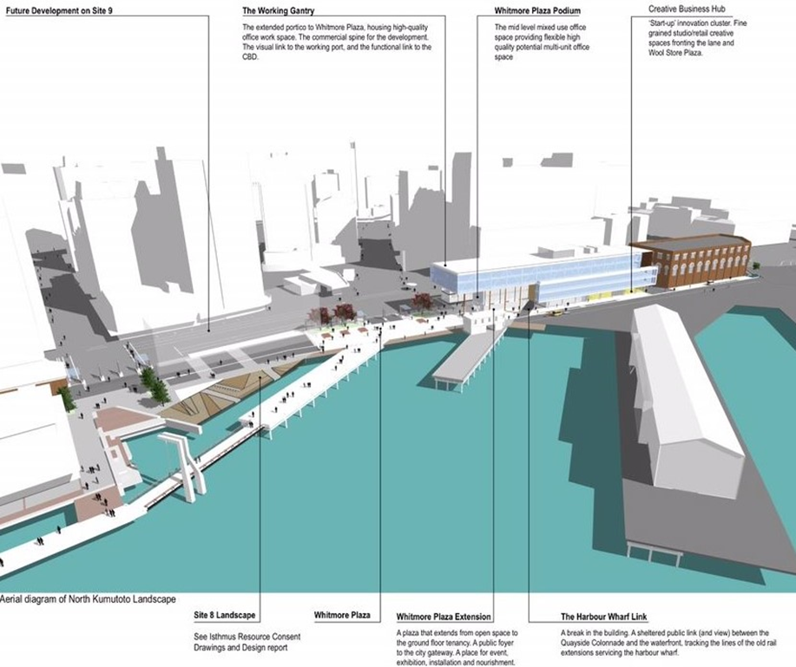
This example of a Willis Bond & Co project by Athfield Architects, represents a sound approach to urban design which celebrates the integration of a new project into an existing urban framework.

Integration of buildings into the existing Milford urban village framework
We ask for an equal quality of integration and detail design for this NZRPG project into the existing Milford ‘urban village’ framework, especially around the periphery of the development, rather than leaving these important matters for future resolution.
We see little regard for any detail design for appropriate and safe pathways for pedestrian and cyclists around the periphery of the Stage 1 development, and can only assume these most important design elements are left for future resolution, if at all as has happened in the past.
In particular we note the following detail design deficiencies :
- Hierarchy of circulation and detail conflict resolution between pedestrians, cycles, cars and service delivery vehicles around the whole Milford shopping centre area, especially at the major access and crossing points of Omana/ Ihumata intersection and Omana Road.

Traffic ingress and egress to those residential properties near the centre will be severely compromised especially at peak traffic times due to conflict with service delivery vehicles, unless a detailed design solution is submitted and peer reviewed during the evaluation process.

- Noise reduction from service delivery vehicles to adjacent residential properties especially between the hours of 7pm to 7am and in weekends
- Infrastructure resolution for stormwater and sediment control, and sewage disposal to ensure adequate provision for future development within the next 5 years.

MRA+MVF suggest that the submitted Stage 1 design proposal provides more benefit to the apartment Owners with its quality views and spaces, but disadvantages or compromise to the community at large due to its large box-like proportions and lack of open space, texture, modulation and landscaped setbacks to the perimeter, and that it needs further refinement to better fit with the context, character, and human scale of Milford

Community Engagement and Resolution
MRA+MVF would like record that there has been no meaningful engagement or discussion by the Developer with key stakeholders as was discussed, and the building height was increased arbitrarily from 9 to 10 storeys with no discussion.
Certainly two meetings were held with the MRA+MVF, but these were only to present a finished design. At one of these meetings, MRA+MVF commented on the boxy effect of the unbroken building bulk and facades, and the dominance of the 10 storey building to the café plaza on the south-east façade, and consequent shading.

Development Contributions
MRA+MVF are adamant that the majority of development contributions should be enforced at the beginning of the project, to finance enhancement of Community amenities and facilities, eg community centre, adjacent natural environment, pocket parks with trees, gardens and quality street furniture.
5.2 Quality of building design
MRA+MVF seek a peer design review of the built form by recognised award-winning Architects to ensure a high quality of design befitting its unique location to ensure an appropriate integration into the existing small scale ‘urban village’ environment
It is important that recognised quality Architects are responsible for the design and materials selected (rather than in-house architects/designers), and for the modulation of roof and façade outlines to express character, texture, individuality and personality, as opposed to the continuous and monotonous slab built form shown in the submission, which we regard as contrary to the expression of Milford as an ‘Urban Village’, and the intent of PC34 Environment court Decision and good Urban Design guidelines.
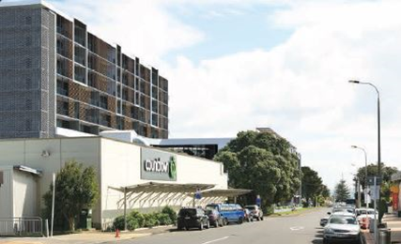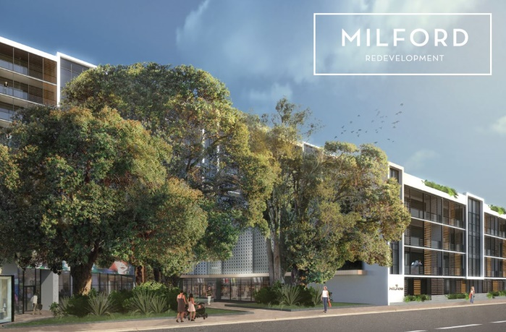
BLAND AND CONTINUOUS FACADES IN THE NZRPG RESOURCE CONSENT SUBMISSION

Compare the above facades to the designs for the Wynyard Quarter by award-winning Architects below
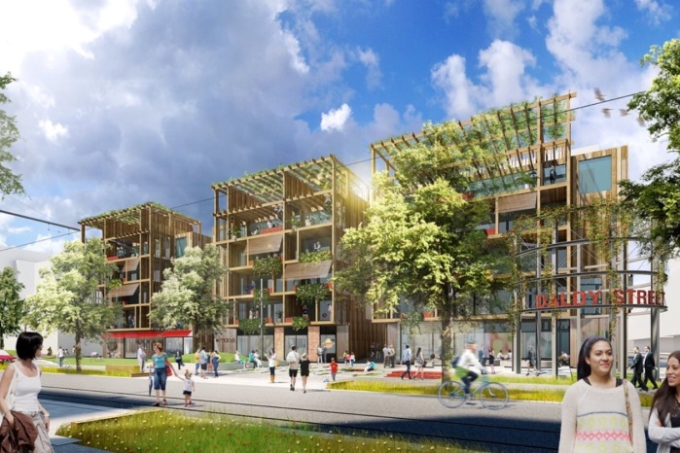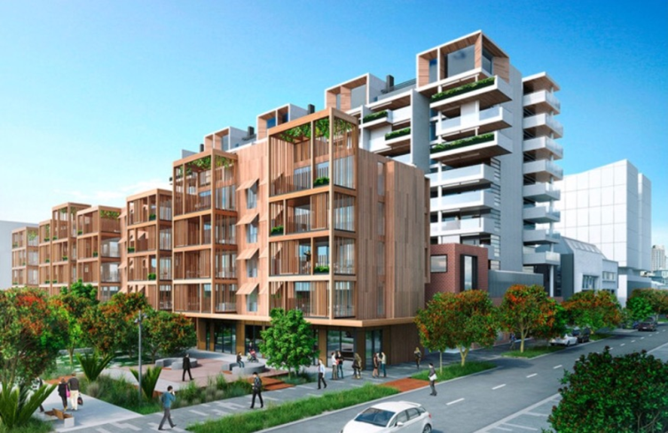

5.3. Creative bulk and massing
MRA+MVF seeks a reduction in the height and length of the building to PC34 maximum heights and building platforms, and greater modulation along the roof line and the building façade to better integrate with Milford’s heritage and human scale, and express the sense of community individualism
The use of slab buildings typical of the Corbusier era may be more economical, but they represent a failed building and community typology compared to the more exciting images of the Wynyard quarter above and overseas cities like Vancouver. Examples of this can be seen in Auckland in the Scene Apartment blocks at the foot of Anzac Ave in the city.
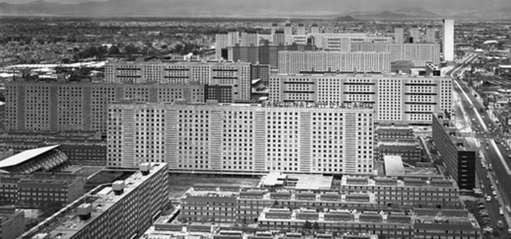
Brazil project in the 1960’s based on Corbusier ideology
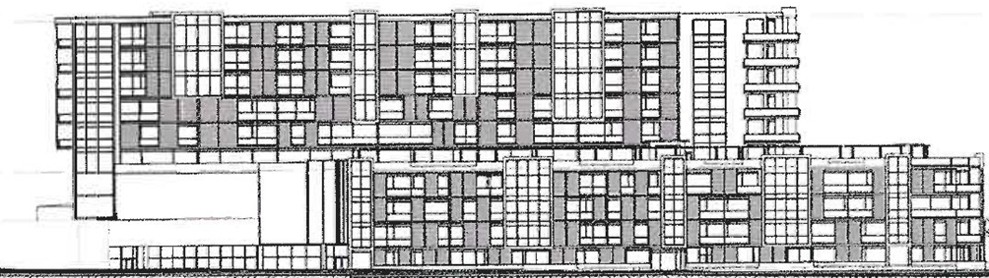
NZRPG elevations represent a similar anonymity (the use of timber screens provides a mitigating feature)
The above elevation differs from the requirements of the Operative District Plan Assessment Criteria as included in the NZRPG submission Fig13, whereby the building is almost 3 times the length permitted in the PC34 Environment Court Decision, and has a diagonal dimension far greater than that permitted in the PAUP.
It is important to note that the building platforms identified in the PC34 Environment Court decision (and supported by Auckland council), are lower in height and less dominating than those in the NZRPG submission, i.e. a maximum height for Building 5 of RL45.0 (not RL46 in the NZRPG submission) and maximum length of 36.7m (not 98.2m in the NZRPG submission), layering down to RL33.0, then to RL27.0, and thence to RL 21.0 (a 3 storey building) on the Milford/ Ihumata Rd frontages.
Should NZRPG accept a redesign of the taller apartments with a more varied skyline and modulation, and lessening of heights at the ends and middle of the 10 storey building (more in line with PC34 – and originally shown to MRA+MVF as 9 storeys), then MRA is willing to negotiate a trade-off to increase the 3 storey PC34 Decision to a 4 storey building along Milford Rd and a 5 storey height on Ihumata Rd, with agreement also being reached on future development on the site.
This is likely to realise a lower height (18m) to the Omana Rd street frontage to the Wairau estuary and the north residential zone, with a setback to upper level floors.

5.4 Public open space on the periphery
MRA seeks amendments to the plans to allow elements of public open space to provide:
- a greater setback to the Milford Rd & Ihumata Rd boundaries
- small pocket parks indented into the façades at the Milford/ Ihumata Rd corner and at midway locations along the Milford Rd façade
- similar pocket parks contracted to be provided along the remaining perimeter facades in Omana Road for future stages (in case sites are sold to other developers with no obligations).
- detail design of spaces to integrate pedestrian & cycle pathways into the periphery of the centre during the evaluation process
- retention of contributions to be spent within the Milford centre area for provision of community amenities and facilities and enhance community identity and well-being

The current documents appear to show the building with balconies directly on the street boundary which is more appropriate in the City Centre, and certainly does not reflect the current residential style and quality on the opposite side of the road for the foreseeable future. (see below)

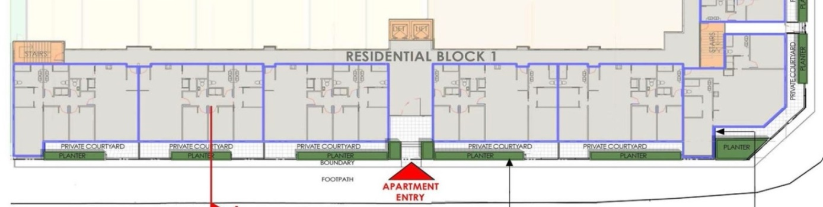

The above harsh building-street interface contrasts with the setbacks shown in the 2009 approved development (below) which is in keeping with the existing residential character of the houses opposite
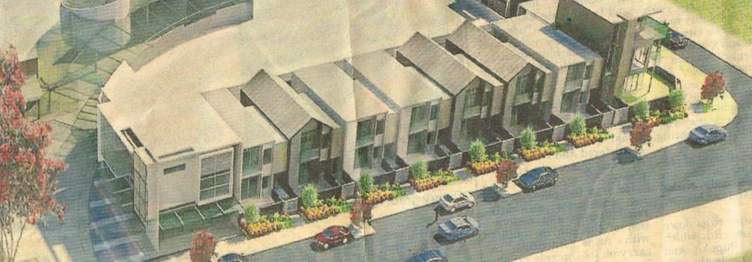

Landscaped building setbacks
MRA+MVF have recently sought relief to the Auckland Unitary Plan Independent Hearing Panel for a 1.5m landscaped setback as per the following figure 1 (shown in dashed green), as well as a further height limitation (18m) on the Omana street frontage as per the whole of the Milford Commercial zone to enhance the feeling of village to pedestrians in the public realm.
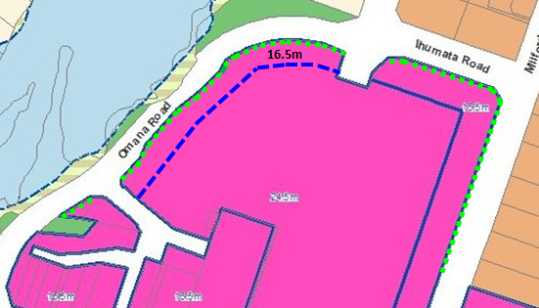

Figure 1: MRA + MVF further submission - Notified PAUP with Proposed amendments
16.5m Lower Height Limitation facing Residential Zones and Wairau Estuary
1.5m Landscaping Setback to Residential zone and Wairau Estuary

5.5 Comments on Ian Munroe evidence in the Urban Design Report
In his Summary of Conclusions, Ian Munroe states a number of personal opinions to build his argument, the outcome of which MRA+MVF dispute:

- That the package of controls ‘to control the width of taller buildings…would not provide for the proposed upper building’s continuous length ( true, but no reason for changing this control)

2. MCL…propose to redistribute (from PC34) building forms and locations to minimise immediate effects on the local environment… (we dispute this rationale)

3. The proposal is based on a different design approach … (sic which has) prioritised the minimisation of adverse effects from taller buildings on immediately adjacent streets and properties (we dispute this theory and contends that the accepted benefits to the apartment owners/dwellers, outweighs to a far greater extent, the benefits to the community at large)

4. The proposal is more effective than the relevant building envelopes in 15P at reducing the visual scale of development (we dispute this theory and contends it will block views from Prospect Tce and have a greater ‘out of context’ impact on the context and character of Milford

Taking into account the increase in low rise base building height proposed, this is superior to 15P, and will reduce perceptions of being visually dominated or overlooked…. and…will have less than minor adverse dominance effects on the street, and minor adverse effects of dominance and overlooking on neighbouring properties (we contend that the combination of 4-5 storey base (above street level) and the 10 storey continuous slab building will have greater deleterious effect on the adjacent residential properties)

Perspectives showing the difference between
3 storeys
a. the Environment Court decision
b. the Unitary Plan heights (in process of amendment)
c. the NZRPG proposed application
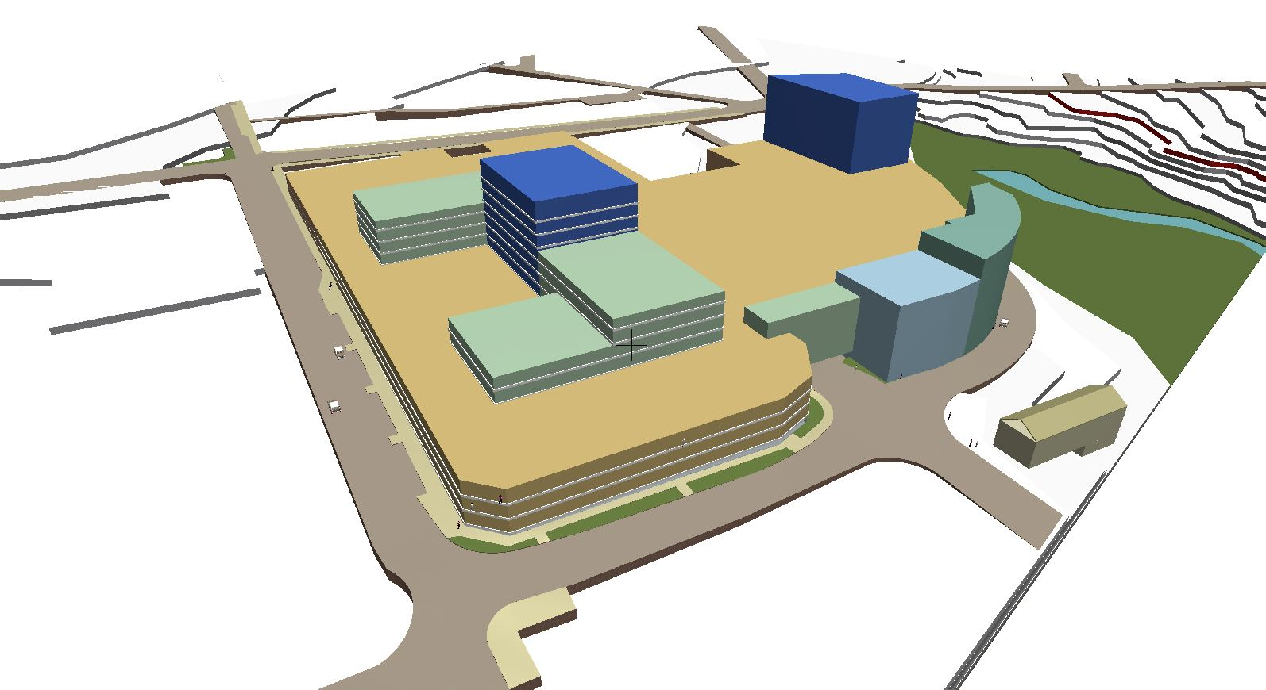
a. ENVIRONMENT COURT FINAL DECISION – 3 Storeys to Milford & Ihumata Rds
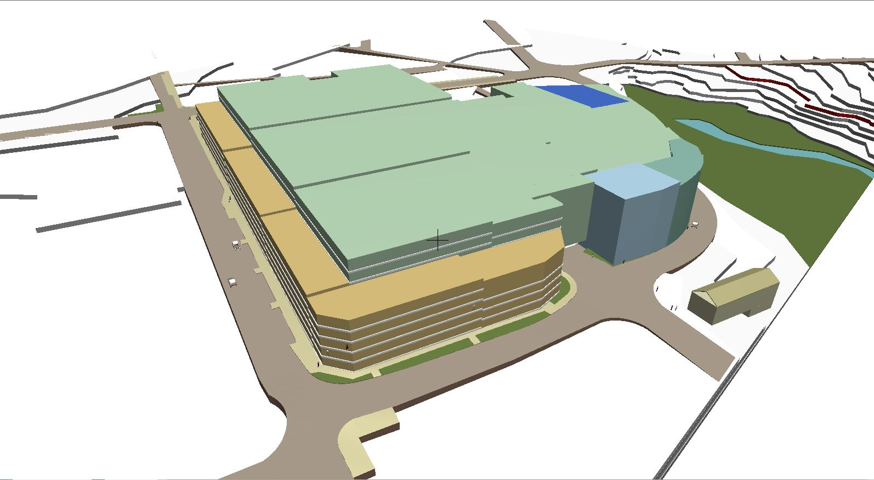
b. CURRENT UNITARY PLAN HEIGHTS – 8 storeys or 24.5m rolling height, 16.5 to Milford Rd
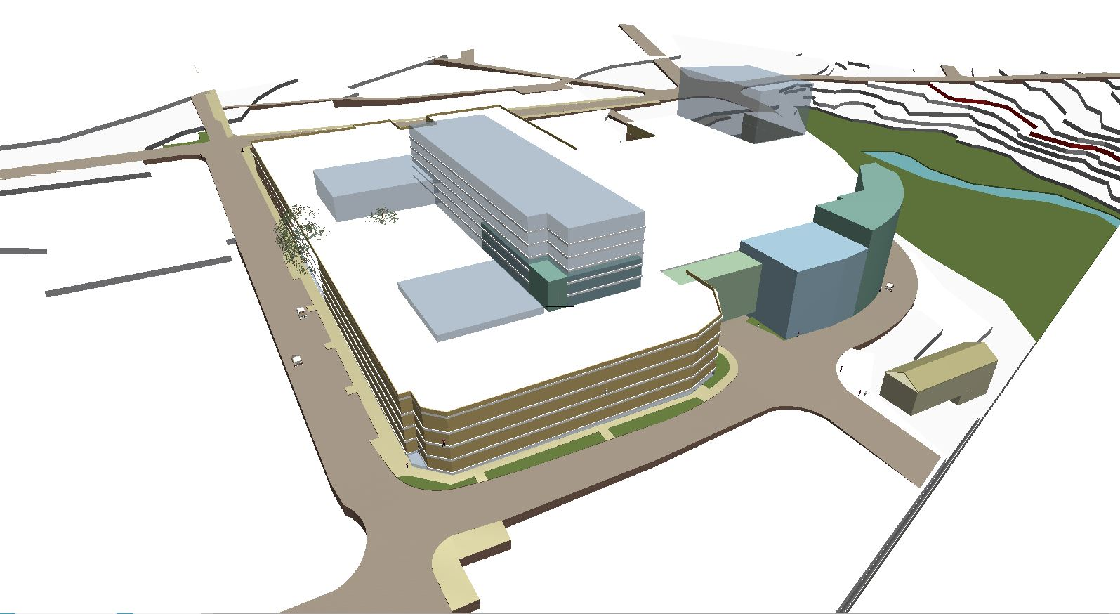,
c. NZRPG PROPOSED APPLICATON – 10 storey building RL45

1. APPENDIX 1 – Key PC34 Decisions of the Environment Court

